Science Review Sheet- Simple Machines

Please study these definitions below:
Power Inclined Plane Screw Wedge
Simple Machine Compound Machine
What 3 simple machines make up a scissor?
What 3 simple machines make up a wheel barrow?

Draw and label arrows to show the input and output forces for the inclined plane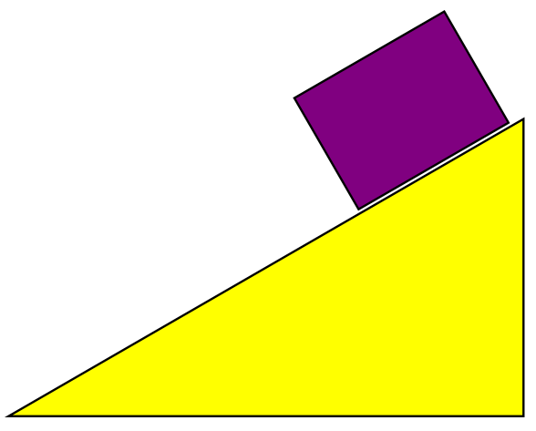
Which of the following is a requirement for work to be done?
  - Force is exerted b. object is carried
- Force moves an object d. machine is used

Which is a simple machine?
  - Baseball bat c. can opener
  - Bicycle d. car

Which of the following is a form of the inclined plane?
  - Pulley c. wheel and axle
  - Screw d. lever

Which is an example of a compound machine?
  - Bicycle c. wheel barrow
  - Can opener d. all of the above

Who was Ruben Goldberg?
  - Artist c. scientist
  - Mathematician d. astronaut

Work measured in which of the following?
  - Joule c. force
  - Newtons d. watts

What is the pivot point of a lever called?
  - Wedge c. fulcrum
  - Pulley d. inclined plane

Which simple machine can create a wedge?
  - Pulley c. inclined plane
  - Lever d. screw

Which is NOT an example of a compound machine?
  - Baseball bat c. bicycle
  - Can opener d. wheel barrow

What simple machine has a grooved wheel that redirects force using a rope?
  - Wedge c. pulley
  - Inclined plane d. screw

What is the unit of measurement of power
  - Joule c. watt
  - Newton d. power

